Gardener F5 Application Load Balancer Extension

Part 5 - Deployment Managers, Typed CMP Clients, Ownership, and Validation
Implementation-grade design for CMP reconciliation, asynchronous operations, retries, ownership, adoption, deletion safety, typed API models, validation, and error classification.
Architecture and Low-Level Design

Document role: This part defines the provider-facing execution boundary shared by the Service and Ingress designs in Parts 3 and 4. It does not redefine Kubernetes semantics; it specifies how an already validated desired-state graph is safely converged through CMP.

Table of Contents
5.1 Scope and Design Objectives
5.2 Layered Architecture and Responsibilities
5.3 Stack Deployer Contract
5.4 Resource Deployment Managers
5.5 Dependency Planning and Action Graph
5.6 Typed CMP Client Architecture
5.7 Typed API Models and Mapping
5.8 Asynchronous CMP Operations
5.9 Idempotency, Retries, and Ambiguous Outcomes
5.10 Discovery, Diffing, and Normalization
5.11 Ownership Identity and Metadata
5.12 Adoption and Conflict Handling
5.13 Validation Before Mutation
5.14 Deletion Safety and Finalization
5.15 Error Classification
5.16 Status, Events, Metrics, and Auditability
5.17 Concurrency, Rate Limiting, and Caching
5.18 Security and Credential Handling
5.19 Testing Strategy
5.20 Package and Interface Design
5.21 CMP Endpoint Mapping
5.22 Sequence Diagrams
5.23 Design Decisions
5.24 Implementation Checklist

5.1 Scope and Design Objectives
Parts 3 and 4 produce a complete desired-state stack. Part 5 defines the execution machinery that turns that stack into an observed CMP/F5 resource graph. The central rule is that provider mutation is never performed directly by a Kubernetes controller or a model builder.

5.1.1 Objectives
- Provide one reusable deployment layer for Service and Ingress stacks.
- Make every reconcile idempotent and restart-safe.
- Represent CMP requests and responses with typed Go models rather than unstructured maps.
- Support asynchronous CMP operations without blocking controller workers indefinitely.
- Prevent accidental adoption, update, or deletion of resources owned by another object or cluster.
- Classify failures into retryable, conflict, permanent, authentication, throttling, and unknown-outcome categories.
- Preserve parent resources while reconciling frequently changing child resources such as pool members.
- Produce auditable decisions, stable identifiers, status conditions, Kubernetes Events, and metrics.

5.1.2 Non-goals
- Embedding Kubernetes API reads inside CMP clients.
- Using CMP response objects as the internal desired-state model.
- Blindly retrying every non-2xx response.
- Inferring ownership from display names alone when stronger metadata is available.
- Deleting resources solely because they are absent from one partial list response.

5.2 Layered Architecture and Responsibilities
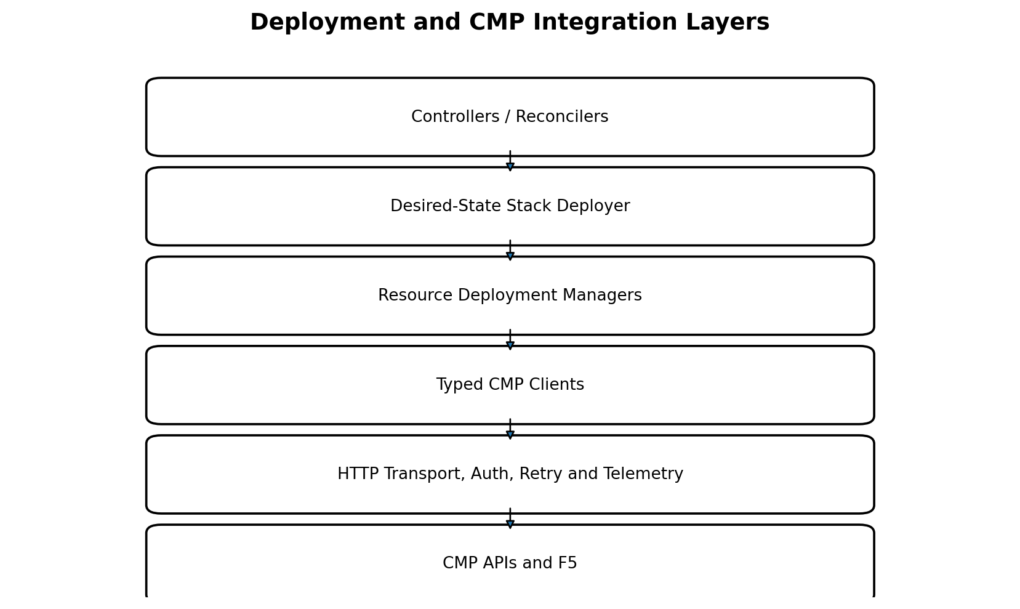
Figure 5-1. Provider-facing layers and dependency direction.
Layer | Owns | Must not own
Controller | Reconcile trigger, input snapshot, final result handling. | CMP endpoint paths, polling loops, resource-specific diffing.
Stack Deployer | Whole-graph plan, dependency order, aggregate result. | Raw HTTP or Kubernetes object parsing.
Resource Manager | Discover, compare, create/update/delete one resource kind. | Authentication and transport implementation.
Typed CMP Client | Typed endpoint operations and response decoding. | Kubernetes semantics or ownership policy decisions.
Transport | HTTP, Ce-Auth/HMAC, deadlines, safe low-level retries, telemetry. | Business-level retries and adoption.
CMP | Authoritative provider state and asynchronous execution. | Kubernetes desired-state intent.

Dependency rule: Dependencies point downward only. Typed clients may be mocked by managers; managers may be mocked by the stack deployer. No lower layer imports controller or Kubernetes reconciliation packages.

5.3 Stack Deployer Contract
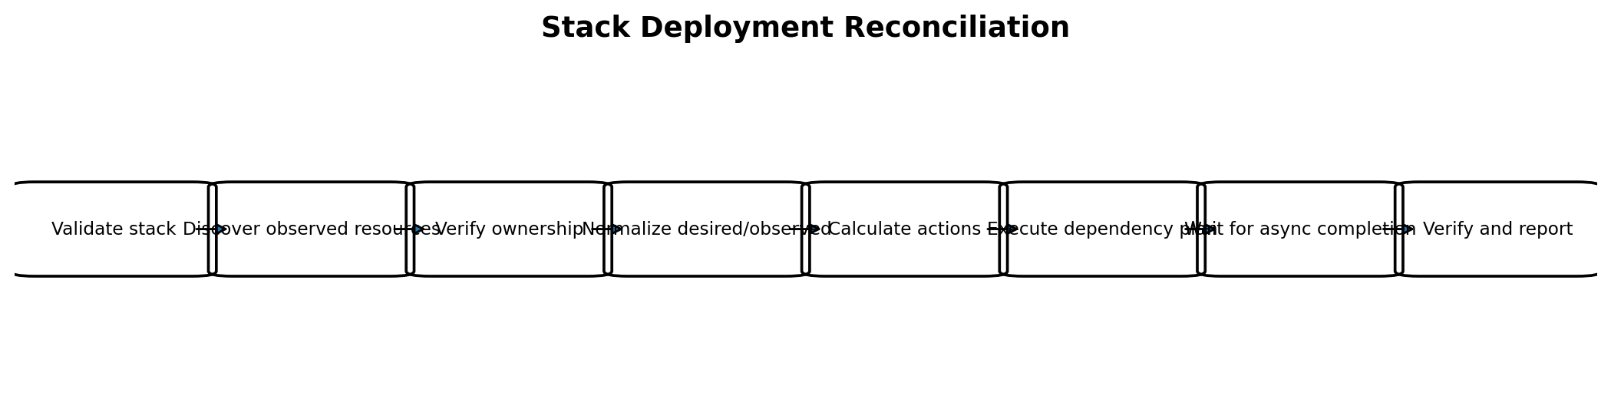
Figure 5-2. Stack-level deployment reconciliation.
The stack deployer coordinates a complete LoadBalancerStack or IngressStack. It receives an immutable desired graph, creates a plan, executes the plan, and returns a provider result that contains stable CMP IDs, the VIP, readiness, warnings, and classified errors.
type StackDeployer interface {
Deploy(ctx context.Context, desired *model.Stack) (*DeploymentResult, error)
Delete(ctx context.Context, owner ownership.OwnerRef) (*DeletionResult, error)
}
type DeploymentResult struct {
ResourceIDs map[model.LogicalID]string
VIPAddress string
Ready bool
Warnings []Warning
ObservedAt time.Time
}

5.3.1 Required Behavior
- Validate the complete desired stack and reject unsafe plans before mutation.
- Discover the current owned graph using persisted IDs and ownership lookup keys.
- Normalize desired and observed values before comparison.
- Construct a dependency-aware action plan.
- Execute actions with bounded concurrency and cancellation.
- Wait only for operations required to establish the next dependency.
- Verify terminal provider state, not merely successful HTTP submission.
- Return partial progress safely so the next reconcile can resume.

5.3.2 Atomicity Model
CMP does not expose one transaction covering the full graph. Therefore atomicity is logical, not database-transactional. The deployer uses ordered convergence and compensating cleanup rather than pretending the graph is created atomically. A failure leaves a discoverable, owned partial graph that the next reconcile continues or removes.

5.4 Resource Deployment Managers
Manager | Primary responsibilities | Parent dependencies
LBServiceManager | Ensure top-level service; expose provider ID and lifecycle state. | None.
VIPManager | Ensure VIP/network port; return address and VIP ID. | LB Service.
VirtualServerManager | Ensure protocol/listener, frontend port, default pool binding and certificate association. | LB Service; VIP semantics.
PoolManager | Ensure pool algorithm and parent relation. | Virtual Server.
MemberManager | Bulk or incremental reconciliation of backend members. | Pool; resolved backend_port_id.
MonitorManager | Ensure health monitor configuration and availability policy. | Pool.
RoutingRuleManager | Ensure deterministic host/path rules and pool targets. | Virtual Server and target Pool.
CertificateManager | Upload/deduplicate certificate and bind it to HTTPS Virtual Server. | LB Service and Virtual Server.

5.4.1 Manager Interface Pattern
type Manager[D any, O any] interface {
Discover(ctx context.Context, scope Scope, key ownership.LookupKey) ([]O, error)
Classify(desired D, observed []O) (MatchResult[O], error)
Create(ctx context.Context, desired D, meta RequestMeta) (OperationRef, error)
Update(ctx context.Context, current O, desired D, meta RequestMeta) (OperationRef, error)
Delete(ctx context.Context, current O, meta RequestMeta) (OperationRef, error)
Verify(ctx context.Context, ref ResourceRef) (O, error)
}
Managers may use specialized methods instead of one generic interface, but all must follow the same lifecycle: discover, ownership-check, compare, mutate, wait, and verify.

5.4.2 Manager Invariants
- A manager never mutates an observed resource until ownership is verified.
- A manager treats HTTP acceptance as submission, not success.
- A manager never creates a duplicate after an unknown outcome without rediscovery.
- A manager reports immutable-field changes to the planner as Replace, not as an unsafe partial patch.
- A manager removes only children whose ownership identity belongs to the desired stack owner.

5.5 Dependency Planning and Action Graph
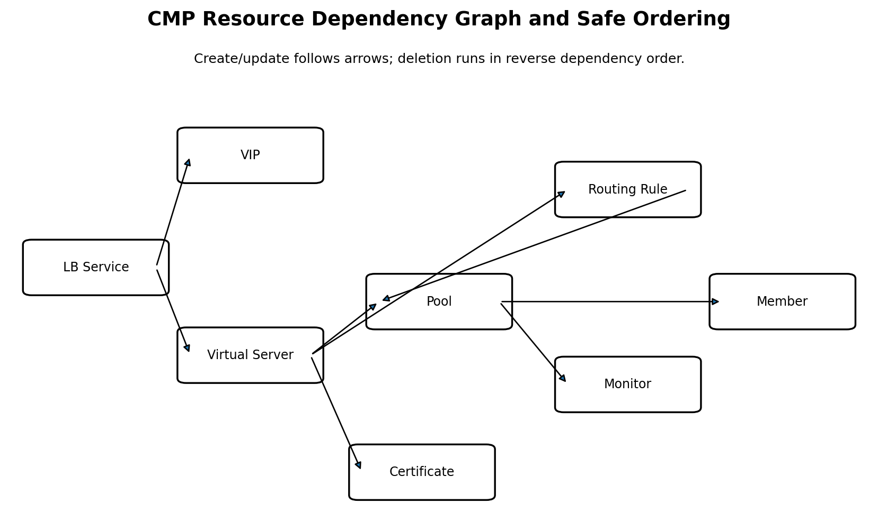
Figure 5-3. Dependency graph used for create/update and reverse-order deletion.

5.5.1 Action Types
Action | Meaning
NoOp | Observed normalized state already equals desired state.
Create | No owned match exists.
Update | Mutable fields differ.
Replace | Immutable identity or parent binding differs.
Delete | Owned observed child is no longer desired.
Adopt | Exact owner match exists but persisted provider ID is absent/stale.
Wait | An asynchronous parent operation must finish before a dependent action.
Blocked | Conflict, failed dependency, validation error, or unsafe ownership state.

5.5.2 Ordering Rules
- Create parents before children.
- Create pools before routing rules that reference them.
- Upload certificates before binding them to a Virtual Server.
- For replacement, create and verify the replacement before removing the old resource when CMP permits coexistence.
- Delete routing rules and bindings before deleting their pools or certificates.
- Delete the LB Service only after all owned children are absent.
Plan(desired, observed):
nodes = classify each desired and observed resource
add dependency edges
reject cycles or unresolved references
topologically sort create/update actions
reverse-topologically sort deletes
insert Wait actions for asynchronous dependencies
return immutable DeploymentPlan

5.6 Typed CMP Client Architecture
The typed client layer maps one-to-one to CMP endpoint families. It hides URLs, headers, serialization, response envelopes, status-code interpretation, and pagination. It does not decide whether an object should exist.
type CMPClients struct {
LBServices LBServiceClient
VIPs VIPClient
VirtualServers VirtualServerClient
Pools PoolClient
Members PoolMemberClient
Monitors MonitorClient
RoutingRules RoutingRuleClient
Certificates CertificateClient
Operations OperationClient
}
type LBServiceClient interface {
List(ctx context.Context, scope TenantScope, filter LBServiceFilter) ([]LBService, error)
Get(ctx context.Context, scope TenantScope, id string) (LBService, error)
Create(ctx context.Context, scope TenantScope, req CreateLBServiceRequest, meta RequestMeta) (OperationRef, error)
Delete(ctx context.Context, scope TenantScope, id string, meta RequestMeta) (OperationRef, error)
}

5.6.1 Transport Responsibilities
- Ce-Auth/HMAC signing and timestamp generation.
- Correlation ID and idempotency/request key headers where supported.
- Per-request deadlines and context cancellation.
- JSON encoding/decoding with strict error handling.
- Response size limits and safe body closure.
- Redaction of credentials, private keys, and authorization material.
- Metrics for endpoint, method, status class, latency, and retry count.

5.6.2 Retry Boundary
Important: The transport may automatically retry only requests proven safe at the HTTP level, such as a GET or a mutation carrying a provider-supported idempotency key. Business retries after 409, 422, unknown outcome, or asynchronous failure belong to managers and require rediscovery.

5.7 Typed API Models and Mapping
Three model families remain deliberately separate: internal desired models, typed CMP request/response DTOs, and normalized observed models. This prevents provider schema changes from leaking into controller logic.
Model family | Example | Purpose
Internal desired model | model.VirtualServer | Stable architecture contract produced by builders.
CMP request DTO | cmp.CreateVirtualServerRequest | Exact JSON schema for one endpoint.
CMP response DTO | cmp.VirtualServerResponse | Provider response including IDs and operation state.
Normalized observed model | deploy.ObservedVirtualServer | Comparable representation after defaults and volatile fields are removed.

type CreatePoolMemberRequest struct {
ResourceID string `json:"resource_id"`
ResourceType string `json:"resource_type"`
BackendPortID string `json:"backend_port_id"`
Address string `json:"ip_address"`
Port int32 `json:"port"`
Weight int32 `json:"weight,omitempty"`
}
type CMPErrorEnvelope struct {
Code string `json:"code,omitempty"`
Message string `json:"message,omitempty"`
Details map[string]any `json:"details,omitempty"`
RequestID string `json:"request_id,omitempty"`
}

5.7.1 Mapping Rules
- Mapping functions are pure and unit-tested.
- Unknown enum values are preserved as Unknown rather than silently mapped to a default.
- Provider-generated fields, timestamps, health, and task state never participate in desired-state equality.
- Sensitive request fields implement safe String methods or are never logged.
- Response envelope parsing tolerates documented variations but fails closed on malformed success responses.

5.8 Asynchronous CMP Operations
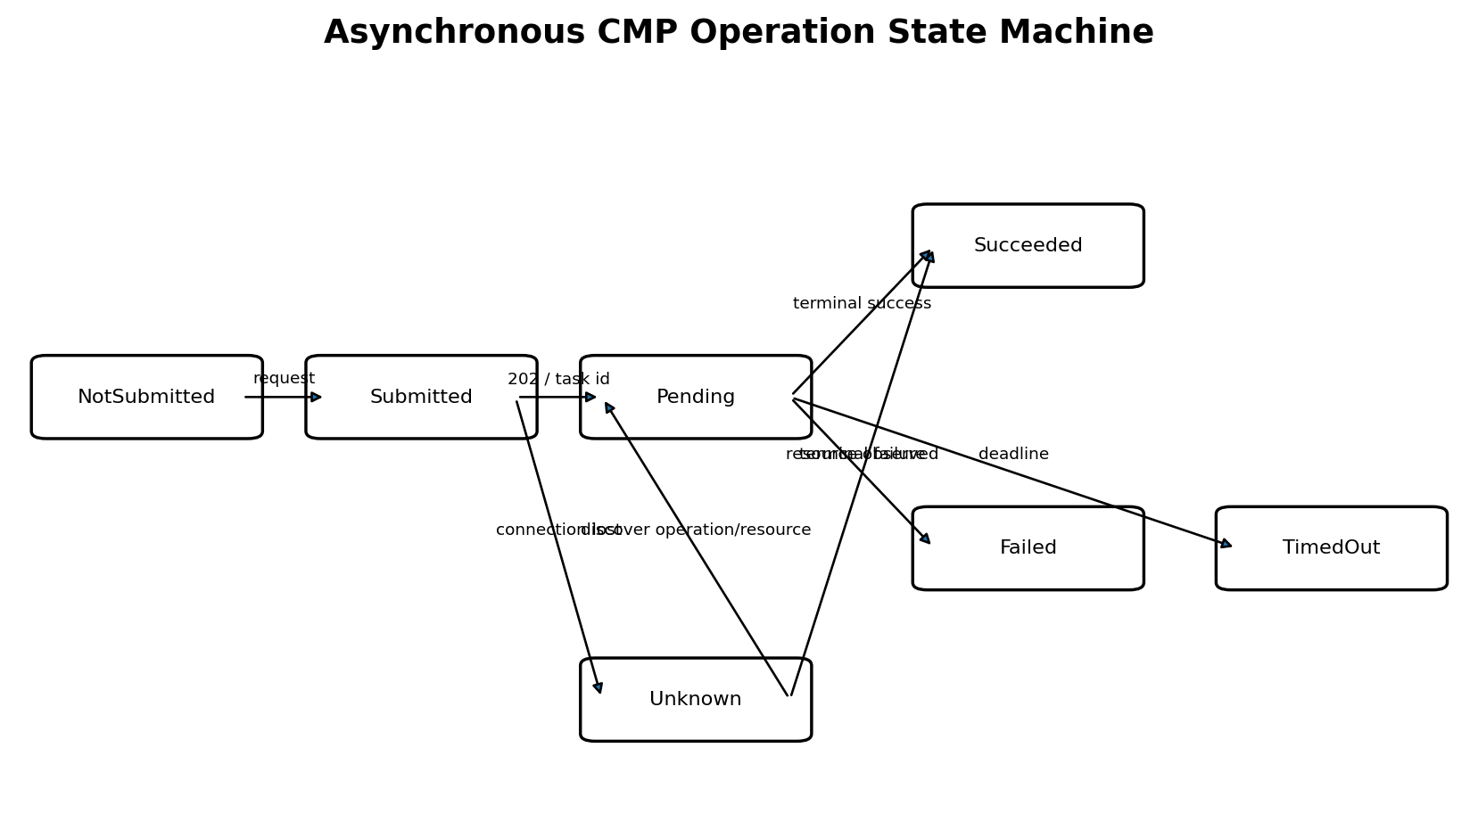
Figure 5-4. State machine for CMP operations that return before F5 completion.
A 202 response means the request was accepted for processing. The controller must not publish readiness or create dependent children until the required provider state is observed.

5.8.1 Operation Reference
type OperationRef struct {
OperationID string
ResourceID string
Kind model.ResourceKind
SubmittedAt time.Time
RequestKey string
PollURL string
}

5.8.2 Polling Algorithm
- Honor Retry-After when supplied; otherwise use bounded exponential backoff with jitter.
- Poll the operation endpoint when available; otherwise poll the resource endpoint and inspect provisioning state.
- Treat terminal success only when CMP reports Active/Succeeded and required fields such as provider ID are present.
- Treat terminal provider failure as a classified operation error containing the CMP request ID.
- Stop polling when the reconcile context deadline is near; return RequeueAfter and resume in the next reconcile.
- After a timeout or lost response, rediscover by request key or ownership key before retrying mutation.
Worker safety: Long provider operations should not hold a controller worker for many minutes. Persist enough operation identity in status/annotations or an internal operation store, return RequeueAfter, and continue polling in later reconciles.

5.9 Idempotency, Retries, and Ambiguous Outcomes

5.9.1 Idempotency Key
Every mutation receives a stable request key derived from cluster identity, owner UID, logical resource ID, desired generation/hash, and operation type. The same logical attempt reuses the same key across transport retries and process restarts.
requestKey = SHA256(
clusterID + ownerUID + logicalID + desiredHash + operationType
)

5.9.2 Retry Matrix
Condition | Default response
Network failure before bytes are written | Retry within transport budget.
Connection lost after request may have reached CMP | Return UnknownOutcome; rediscover before any new mutation.
HTTP 408/429/502/503/504 | Retry with jitter and Retry-After, bounded by context and rate limiter.
HTTP 409 | Rediscover and re-diff; may indicate concurrent operation or name conflict.
HTTP 401/403 | Do not loop aggressively; classify Auth/Authorization and surface condition.
HTTP 400/422 | Permanent until desired input changes; report validation/provider rejection.
Operation terminal failure | Classify provider code; retry only when explicitly transient.
Malformed success response | Treat as protocol error; do not assume success, rediscover.

5.9.3 Unknown Outcome Recovery
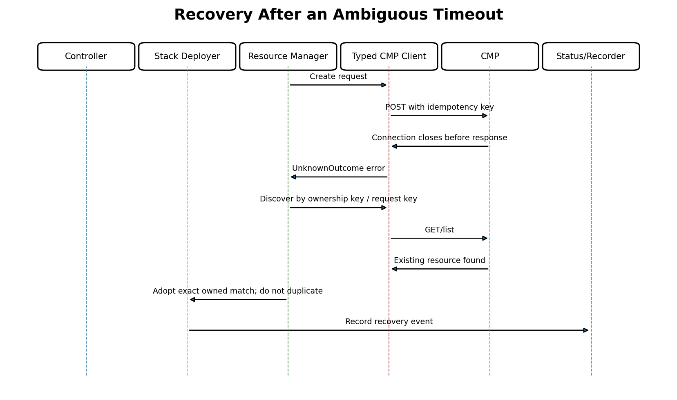
Figure 5-5. Rediscovery prevents duplication after a lost create response.

5.10 Discovery, Diffing, and Normalization

5.10.1 Discovery Sources
- Provider IDs persisted from a prior successful reconcile.
- Exact ownership metadata or deterministic ownership lookup key.
- Parent-scoped listing, for example pools under one Virtual Server.
- Name lookup only as a secondary hint; it never proves ownership by itself.

5.10.2 Normalization
Field type | Normalization
Provider defaults | Materialize the documented default in both desired and observed forms.
Ordering | Sort members, rules, certificates, and monitors by stable logical identity.
Names | Apply the same truncation, character replacement, and hash suffix algorithm.
Empty versus null | Canonicalize semantically equivalent values.
Protocol/enums | Normalize casing and aliases.
Volatile state | Exclude timestamps, task IDs, health samples, and provider-generated labels from equality.
Secrets | Compare certificate fingerprint, never private-key bytes in logs or status.

func Equivalent(desired DesiredPool, observed ObservedPool) bool {
d := NormalizeDesiredPool(desired)
o := NormalizeObservedPool(observed)
return cmp.Equal(d, o)
}

5.10.3 Drift Categories
Drift | Action
Mutable configuration drift | Patch/update.
Missing owned resource | Create/recreate.
Extra owned child | Delete after reference and ownership checks.
Immutable field drift | Replace according to planner.
Foreign resource collision | Block and report OwnershipConflict.
Provider-only health degradation | Do not overwrite desired config; report readiness and retry verification.

5.11 Ownership Identity and Metadata
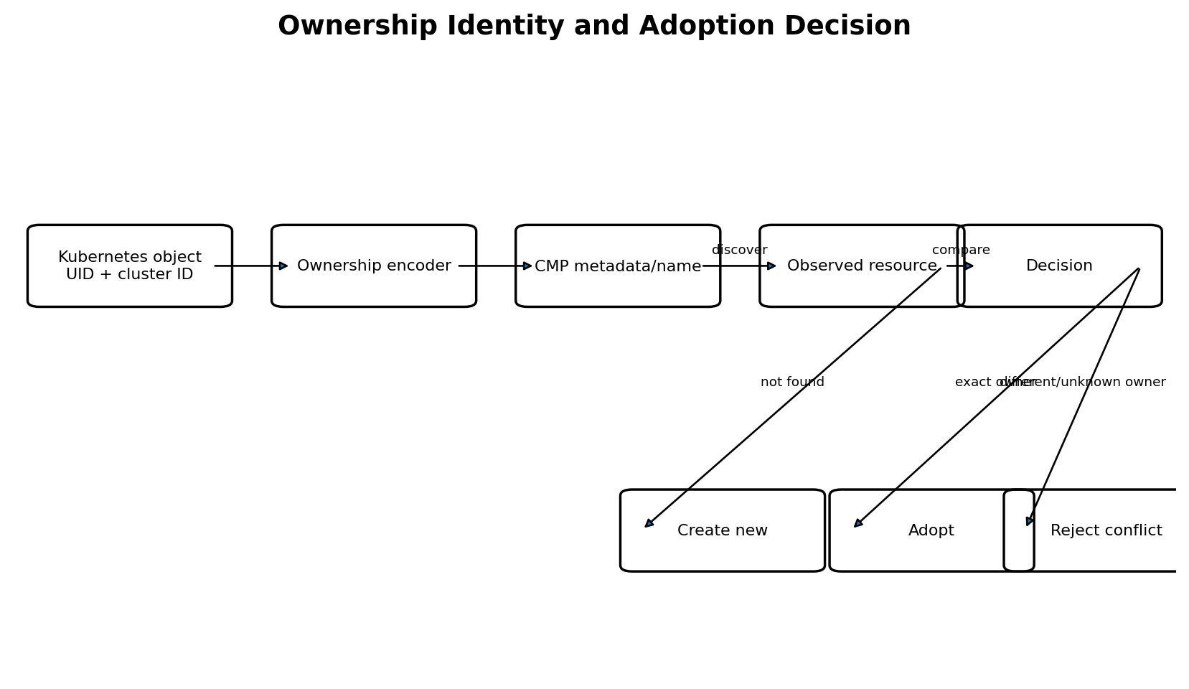
Figure 5-6. Ownership encoding, discovery, and decision points.
Ownership prevents two clusters, controllers, Services, or Ingress groups from controlling the same CMP resource. The owner identity is generated by the extension; it is not supplied by an application user.

5.11.1 OwnerRef
type OwnerRef struct {
ClusterID string
Kind string // Service or IngressGroup
Namespace string
Name string
UID types.UID
GroupKey string
Controller string
}

5.11.2 Required Ownership Fields
Field | Purpose
managed-by | Stable controller identifier.
cluster-id | Separates resources from different Shoot clusters.
owner-kind | Service or IngressGroup.
owner-uid | Strong Kubernetes lifecycle identity; name reuse does not inherit ownership.
logical-id | Stable identity of the child inside the stack.
desired-hash | Optional drift and operation diagnostic.
source-namespace/name | Human-readable troubleshooting only; not sufficient for proof.

5.11.3 Storage Strategy
Preferred order: structured CMP tags/metadata; explicit description fields if queryable; deterministic names containing a short ownership hash as a fallback. The implementation should use the strongest available mechanism for each CMP resource type and record the strategy in the observed model.
Name safety: Display names may include readable prefixes, but ownership verification must use owner UID and cluster identity encoded in metadata or a collision-resistant hash. Namespace/name alone is unsafe because Kubernetes objects can be deleted and recreated.

5.12 Adoption and Conflict Handling

5.12.1 Adoption Rules
Observed situation | Decision
Persisted ID resolves and owner matches | Continue managing.
Persisted ID missing; exact ownership-key match found | Adopt and refresh persisted ID.
One exact owner match with stale desired hash | Adopt, then reconcile drift.
Multiple exact-looking matches | Block; manual investigation required.
Same name but no ownership metadata | Do not adopt automatically.
Different cluster ID or owner UID | Foreign resource conflict; never mutate.
Legacy resource with approved migration marker | Adopt only through explicit migration mode and audit event.

5.12.2 Adoption Preconditions
- Resource kind and parent chain match the desired logical resource.
- Tenant/project/network scope matches.
- Owner UID and cluster identity match exactly, or a controlled legacy migration rule applies.
- No second candidate exists.
- Adoption will not steal a resource referenced by another managed graph.

5.12.3 Conflict Status
Ownership conflicts are permanent until the external state or desired identity changes. The controller sets a clear condition such as Ready=False, Reason=OwnershipConflict, emits a Warning event, and does not continuously hammer CMP with mutations.

5.13 Validation Before Mutation
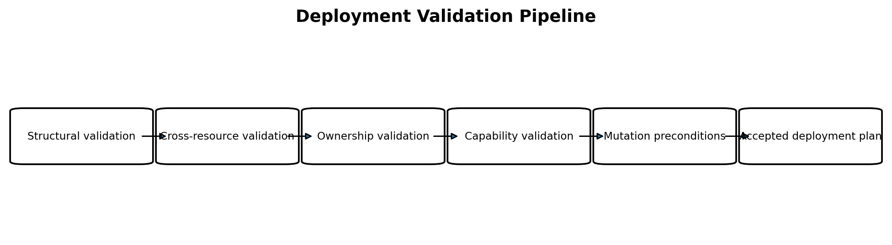
Figure 5-7. Deployment-layer validation performed after model building and before CMP mutation.
Stage | Checks
Structural | Required logical IDs, parent references, unique child identities, valid port ranges.
Cross-resource | Every rule target pool exists; certificate binding targets HTTPS listener; member parent exists.
Ownership | OwnerRef complete; logical IDs deterministic; no foreign observed match selected.
Capability | CMP endpoint and feature support; count and payload limits; mutable versus immutable fields.
Mutation preconditions | Credentials available; tenant/project/network scope resolved; dependencies terminal and healthy enough.
Delete preconditions | Expected owner, expected parent, no remaining desired/reference dependency, fresh read performed.

5.13.1 Validation Result
type ValidationResult struct {
Errors []FieldError // blocks all mutation
Warnings []Warning // may continue, surfaced in status/events
}
Fail closed: When ownership or parent identity cannot be proved, the correct behavior is to stop mutation, not to guess. Availability may temporarily remain on the last-known-good graph while the new desired generation is reported as rejected.

5.14 Deletion Safety and Finalization
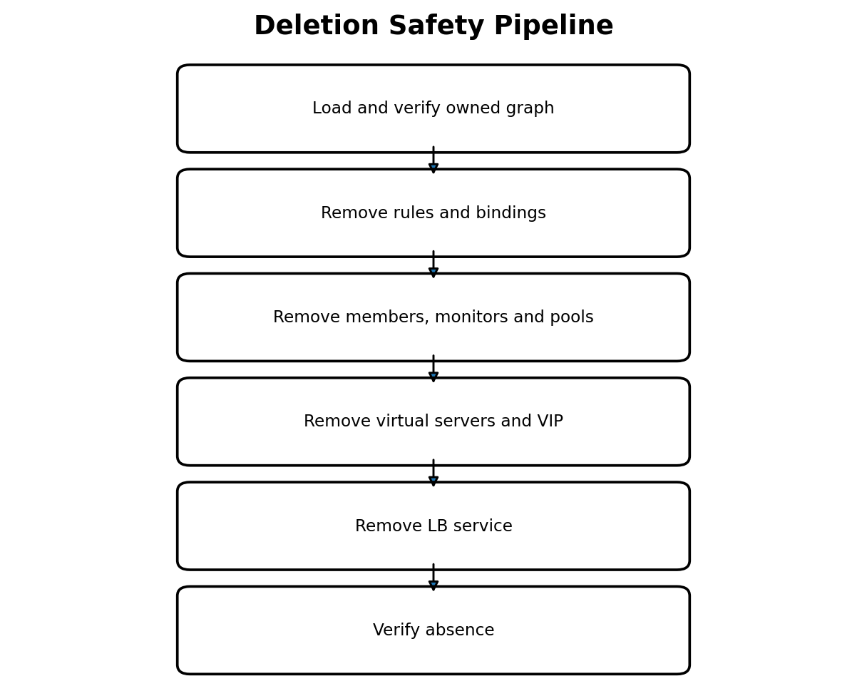
Figure 5-8. Reverse dependency deletion with repeated ownership verification.

5.14.1 Safety Rules
- Re-read each resource immediately before deletion.
- Verify owner UID, cluster ID, logical ID, resource kind, and expected parent.
- Delete only resources in the owner graph; never broad-delete by display-name prefix.
- Treat 404 as successful absence after the ownership decision has been made from prior state.
- Wait for asynchronous child deletion when CMP prevents parent deletion.
- Retain the Kubernetes finalizer until the provider graph is absent or a documented orphan policy is explicitly chosen.

5.14.2 Shared Resource Deletion
Ingress groups and shared frontend resources require graph-level reference counting from the desired group model. Removing one Ingress deletes only its rules, pools, members, monitors, or certificates that no remaining group member references. The LB Service, VIP, and listeners remain until the group is empty.

5.14.3 Stuck Deletion
Cause | Handling
CMP transient outage | Requeue with bounded backoff; finalizer remains.
Foreign child blocks parent deletion | Report OwnershipConflict; do not delete foreign child.
Credential revoked | Report AuthenticationFailed and alert; finalizer remains by default.
Provider resource manually removed | Verify 404/absence and continue cleanup.
Irrecoverable provider defect | Require explicit operator-approved orphan policy; never silently remove finalizer.

5.15 Error Classification
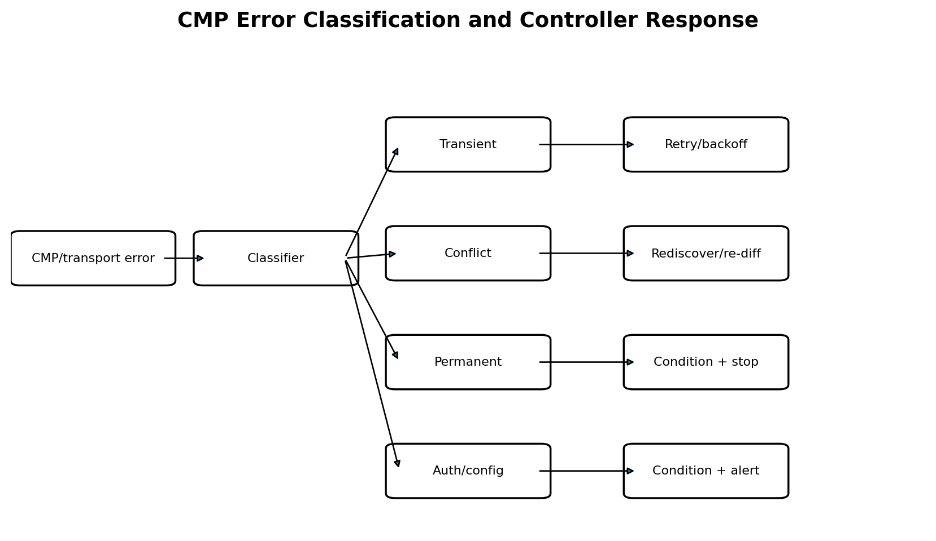
Figure 5-9. Error classes drive distinct reconcile behavior.
type ErrorClass string
const (
ErrTransient ErrorClass = "Transient"
ErrThrottled ErrorClass = "Throttled"
ErrConflict ErrorClass = "Conflict"
ErrValidation ErrorClass = "Validation"
ErrAuthentication ErrorClass = "Authentication"
ErrAuthorization ErrorClass = "Authorization"
ErrNotFound ErrorClass = "NotFound"
ErrUnknownOutcome ErrorClass = "UnknownOutcome"
ErrProtocol ErrorClass = "Protocol"
ErrPermanent ErrorClass = "Permanent"
)
Class | Examples | Controller behavior
Transient | 502/503/504, connection reset, temporary provider failure. | Retry with jitter and rate limiting.
Throttled | 429 or quota pacing response. | Honor Retry-After; reduce concurrency.
Conflict | 409, operation already running, ownership/name collision. | Rediscover; retry only if convergence can resolve it.
Validation | 400/422 caused by desired payload. | Set condition; wait for Kubernetes input change.
Authentication/Authorization | 401/403. | Stop aggressive retries; alert and periodically recheck.
NotFound | 404. | Context-dependent: absence on delete is success; absence on required parent triggers rebuild.
UnknownOutcome | Response lost after mutation may have executed. | Rediscover before retry.
Protocol | Malformed response, missing ID on success. | Rediscover and surface integration defect.
Permanent | Unsupported provider state or unrecoverable operation. | Condition and operator action.

5.15.1 Structured Provider Error
type ProviderError struct {
Class ErrorClass
Operation string
Resource model.LogicalID
HTTPStatus int
ProviderCode string
RequestID string
RetryAfter time.Duration
Cause error
}

5.16 Status, Events, Metrics, and Auditability

5.16.1 Result Propagation
Signal | Contents
Kubernetes condition | Ready/Programmed, reason, concise message, observedGeneration.
Event | Important transition: created, adopted, conflict, async failure, deletion blocked.
Structured log | Owner, logical ID, provider ID, operation, request ID, elapsed time, error class.
Metric | Requests, latency, operations pending, retries, conflicts, resources, reconcile duration.
Trace | Controller reconcile -> manager action -> CMP request/poll chain.
Audit record | Adoption, ownership conflict, orphan override, destructive replacement.

5.16.2 Logging Rules
- Use correlation IDs across initial mutation and subsequent polls.
- Never log Ce-Auth secrets, private keys, full certificate bodies, tokens, or unredacted request headers.
- Log provider request IDs because they are essential for CMP support diagnostics.
- Avoid logging complete backend lists at info level; use counts and hashes, with sampled debug details.

5.17 Concurrency, Rate Limiting, and Caching

5.17.1 Concurrency Model
- Serialize deployment for the same OwnerRef using keyed locking or controller workqueue guarantees.
- Allow bounded parallelism across unrelated owners.
- Within one stack, parallelize independent branches only after their parents are ready.
- Use a global CMP rate limiter plus endpoint-specific limits for expensive operations.
- Do not run two mutations concurrently against the same CMP resource or parent collection unless explicitly supported.

5.17.2 Cache Policy
Data | Cache recommendation
Static capability/configuration | Cache with version or TTL.
Tenant/project/network resolution | Short TTL; invalidate on authorization/not-found errors.
Operation result | Persist/recover; do not rely only on in-memory cache.
Resource lists | Use only within one reconcile snapshot; refresh before destructive action.
Credentials | Use secret-backed provider and short-lived memory; never persist plaintext.

5.18 Security and Credential Handling
- Use a dedicated CMP credential with minimum permissions for the target organization/project.
- Read credentials through a provider interface backed by Kubernetes Secret or Gardener extension secret plumbing.
- Sign each request at send time; avoid reusing stale timestamps/nonces.
- Use TLS verification with managed trust roots; no insecure-skip-verify in production.
- Redact all sensitive headers and payload fields in logging and tracing.
- Set strict request timeouts, response-size bounds, and JSON decoding limits.
- Validate all CMP IDs and URL path components before construction.
- Separate certificate private-key handling from normal DTO logging and metrics.

5.19 Testing Strategy
Test layer | Coverage
Pure unit tests | Normalization, mapping, ownership encoding, action classification, error classifier.
Manager unit tests | Create/update/no-op/replace/delete/adopt using fake typed clients.
Planner tests | Dependency order, cycles, shared references, reverse deletion, partial failures.
HTTP contract tests | Exact methods, paths, headers, JSON bodies, envelope parsing, pagination.
Async tests | 202 polling, Retry-After, timeout, terminal failure, process restart, unknown outcome.
Fault injection | Dropped response after create, 429 storms, stale lists, malformed success body, duplicate candidate.
Integration tests | Mock CMP server with realistic lifecycle and eventual consistency.
End-to-end tests | Kubernetes Service/Ingress through extension into a test CMP/F5 environment.

5.19.1 Required Golden Scenarios
- Controller restart after CMP accepted create but before status write.
- Pool exists but one member and monitor are missing.
- Two resources share a display name but only one carries the correct owner UID.
- Delete is requested while CMP reports an operation already in progress.
- Certificate update requires replacement and rebinding without breaking unrelated hosts.
- A foreign routing rule references an owned pool; deletion must stop and report conflict.

5.20 Package and Interface Design
pkg/
model/ # desired-state contracts from Part 2
deployment/
stack/ # planner and orchestration
lbservice/
vip/
virtualserver/
pool/
member/
monitor/
routingrule/
certificate/
ownership/
validation/
errors/
operation/
cmp/
clientset.go
transport/
auth/
lbservice/
vip/
virtualserver/
pool/
member/
monitor/
routingrule/
certificate/
operation/
observability/

5.20.1 Key Interfaces
type OperationWaiter interface {
Wait(ctx context.Context, ref OperationRef) (OperationResult, error)
}
type OwnershipVerifier interface {
Verify(expected OwnerRef, observed ResourceMetadata) error
}
type Planner interface {
Build(desired *model.Stack, observed *ObservedGraph) (*DeploymentPlan, error)
}
type ErrorClassifier interface {
Classify(err error, response *http.Response) *ProviderError
}

5.21 CMP Endpoint Mapping
The following endpoint families were identified in the supplied CMP Compute Swagger. Exact request/response schemas remain encapsulated in typed clients so the rest of the extension does not depend on URL structure.
Resource | CMP endpoint family | Operations used
LB Service | /load-balancers/domain/{organization_id}/project/{project_id}/load-balancers/lb_service/ | GET list, POST create; GET/DELETE by lb_service_id.
VIP | .../lb_service/{lb_service_id}/vip | GET list, POST create; DELETE by vip_id.
Virtual Server | .../load-balancers/{lb_service_id}/virtual-servers | GET list, POST create; GET/PATCH/DELETE by virtual_server_id.
Routing Rule | .../lb_service/{lb_service_id}/virtual-servers/{virtual_server_id}/routing-rules | GET, POST; DELETE by routing_rule_id.
Certificate | .../load-balancers/{lb_service_id}/certificates | GET, POST; DELETE by certificate_id; bind via Virtual Server certificate endpoint.
Pool | .../virtual-servers/{virtual_server_id}/pools | POST; GET/DELETE by pool ID; set-default endpoint.
Pool Member | .../pools/{pool_id}/members | POST; PUT/DELETE by member ID; health and operating-status endpoints.
Monitor | .../pools/{pool_id}/monitors | GET/POST/PUT; PATCH/DELETE by monitor ID.
Health | Virtual Server and member health-check endpoints. | GET for readiness/diagnostics, not desired-state ownership.

Version isolation: Endpoint versioning, response envelopes, and future CMP schema changes are localized to cmp/* packages. Deployment managers consume stable domain-level client interfaces.

5.22 Sequence Diagrams
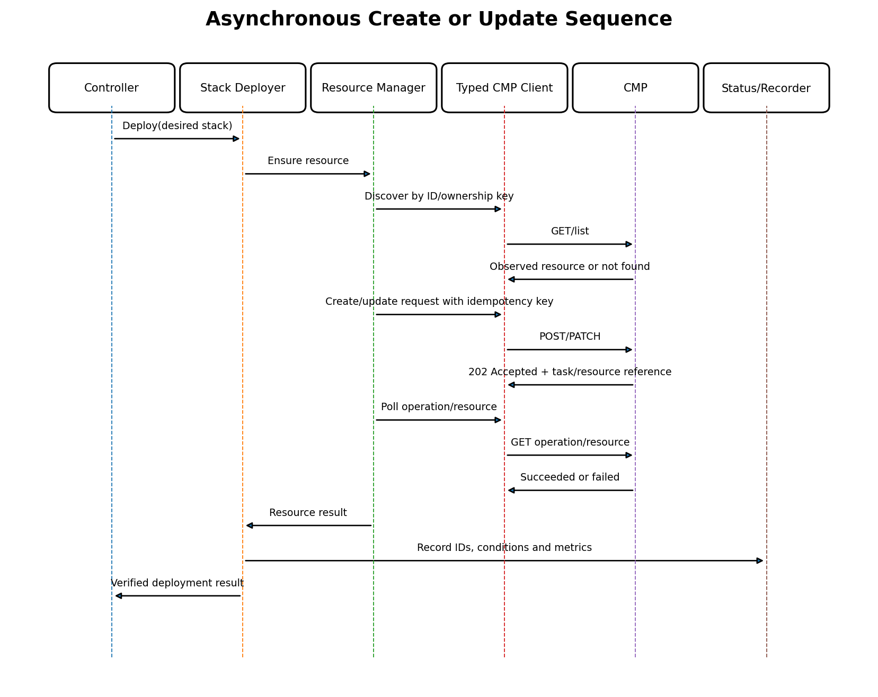
Figure 5-10. End-to-end asynchronous create/update with verification.
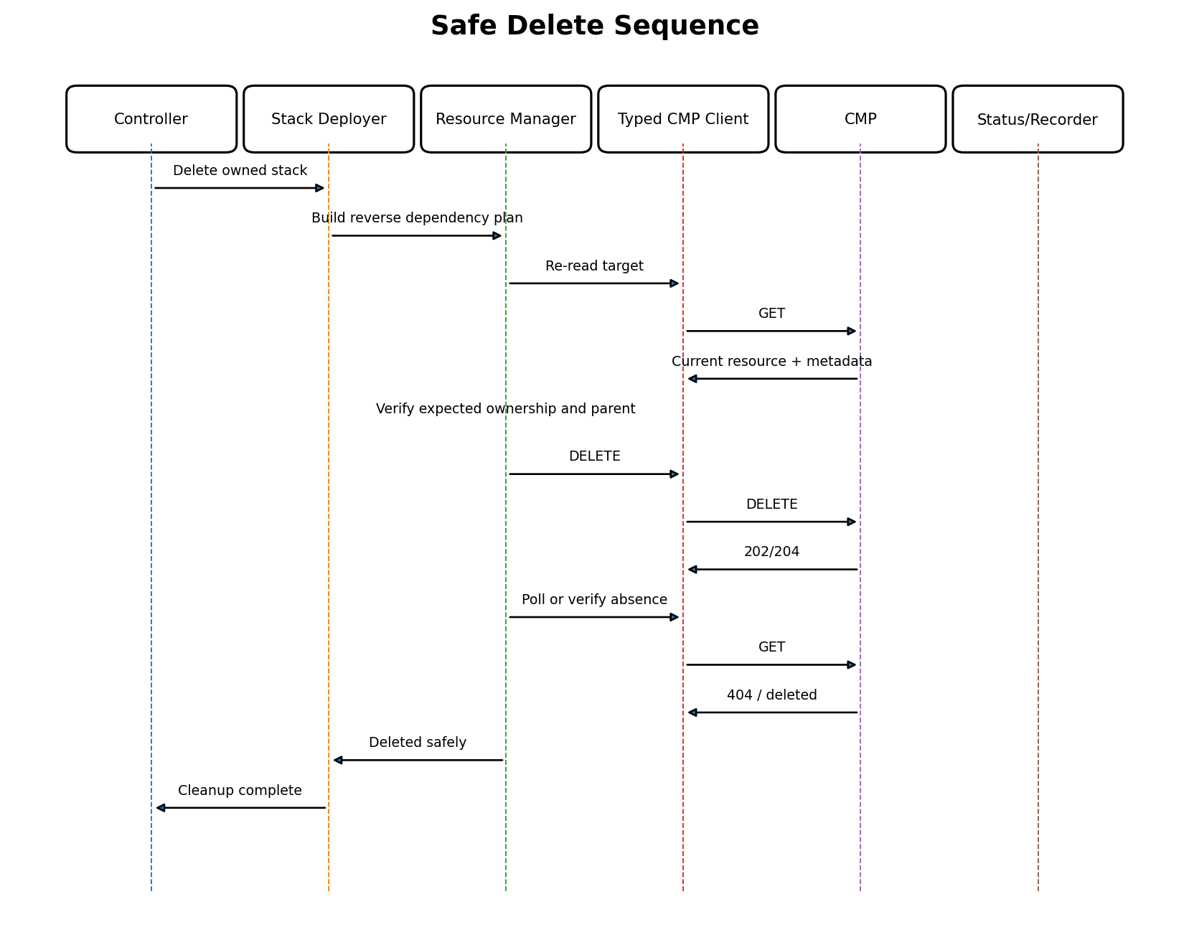
Figure 5-11. Safe deletion re-verifies ownership immediately before mutation.

5.23 Design Decisions
Decision | Rationale
One stack deployer shared by Service and Ingress | Avoids divergent provider behavior and duplicate safety logic.
Resource-specific managers | CMP lifecycle and update semantics differ by resource kind.
Typed clients below managers | Separates transport/API schema from reconciliation policy.
Desired and observed normalization | Prevents endless updates caused by defaults, ordering, or volatile fields.
Owner UID + cluster identity | Protects against Kubernetes name reuse and cross-cluster collisions.
Adoption requires exact proof | Availability is less important than avoiding resource theft or corruption.
Async operations resume across reconciles | Prevents blocked workers and supports restart recovery.
Unknown outcome triggers discovery | Blind retries can create duplicate provider resources.
Deletion in reverse dependency order | Matches CMP referential constraints and minimizes partial failures.
Error classification is first-class | Different failures require different retry and user-visible behavior.

5.24 Implementation Checklist

Foundation
☐ Define domain client interfaces and typed DTOs.
☐ Implement transport, Ce-Auth/HMAC, correlation IDs, redaction, deadlines.
☐ Implement structured ProviderError and classifier.

Ownership
☐ Define OwnerRef and deterministic logical IDs.
☐ Implement metadata/name encoding and exact verifier.
☐ Implement adoption decision matrix and conflict conditions.

Deployment
☐ Implement observed graph and normalization.
☐ Implement resource managers.
☐ Implement planner and dependency execution.
☐ Implement asynchronous operation waiter and resume state.

Safety
☐ Implement mutation precondition validation.
☐ Implement reverse-order deletion and fresh ownership read.
☐ Implement shared-resource reference handling.

Operations
☐ Add conditions, Events, metrics, traces, and provider request IDs.
☐ Add rate limiting, bounded concurrency, and credential refresh.
☐ Complete contract, fault-injection, integration, and end-to-end tests.
Completion criterion: Part 5 is complete when controllers can pass a desired stack to the deployment layer without knowing CMP URLs or payloads, and the layer can safely converge, recover, adopt, reject conflicts, and delete resources under restarts and partial provider failures.

